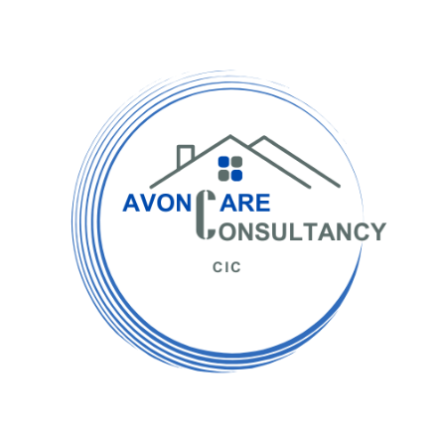

1. WHAT WE COLLECT
- Contact Information: name, phone, email, address
- Service Information: only where necessary for consultancy work
- Technical Info: anonymized IP address and browsing activity
2. HOW WE USE YOUR DATA
- Respond to inquiries
- Deliver services
- Comply with legal or regulatory obligations
- Improve website experience
3. LEGAL BASIS FOR PROCESSING
- Your consent
- Legitimate interest to operate and grow our services
- Legal obligations
4. DATA SHARING
We may share information with:
- Regulatory bodies (e.g. CQC or similar)
- Health professionals (for consultancy purposes)
- IT service providers for hosting/security
No data is sold. Data is stored securely and never transferred outside the UK or EEA without safeguards.
5. DATA RETENTION
Data is retained only as long as necessary — typically 6 months after your last interaction unless required longer by law.
6. YOUR RIGHTS
You have the right to:
- Access your data
- Request correction
- Request deletion
- Object to processing
- Lodge complaints with the ICO (ico.org.uk)

